**NGF COLLEGE OF ENGINEERING AND TECHNOLOGY, PALWAL (HARYANA)**



**PROJECT REPORT**

**ON**

**INGFCET PIZZERIA**

**Submitted To**

**Ms. Sonu Sharma**

**Assistant Professor**

**Submitted By**

**Ishwa**

**B. tech (CSE 3rd Year)**

**6th Sem**

**S19CSE022**

**PROJECT REPORT ON**

**INGFCET PIZZERIA**

**LIST OF CONTENT**

1. Introduction
2. Objective
3. System Requirement
4. System Analysis
5. Data flow diagram
6. Outputs
7. Conclusion
8. Future scope

**INGFCET Pizzeria**

**Introduction**

The INGFCET Pizzeria System helps the canteen manager to manage the college canteen more effectively and efficiently by computerizing meal ordering, billing and inventory control. This management system is designed for a College Canteen. The system processes transaction and stores the resulting data. Reports will be generated from these data which help the manager to make appropriate business decisions for the canteen.

This will help the canteen owner in many ways such as ordering goods, inventory control, generating bills, managing tables, managing menus, and various customer services.

**Objective**

This objective of the project is :

* To update current canteen systems.
* To update current canteen systems.
* To simplify and make it easier to manage.
* To control every records of canteen.
* To manage all the stock.
* To check or view every details of canteen.

**System Requirement**

**Hardware Requirement:**

Processor Brand : Intel

Processor Type : Core i5

Processor Speed : 2.40GHz

Ram Size : 8.00 GB

**Software Requirement**

Operating system : Windows 10

Application Server : Java (NetBeans)

Front end : JAVA

Database connectivity : XAMPP (MYSQL Console)

**System Analysis**

The INGFCET Pizzeria System software is specifically designed with features to help operate and manage the canteen.

This system will help the canteen manager to manage the college canteen more effectively and efficiently by computerizing meal ordering, billing and inventory control.

The aim of the project is to offer variety of food to college students and helps the canteen manager to manage the canteen more effectively and also save his time.

**Data Flow Diagram**

Images of food

Details of all Menu Items

Manage the stock by Update/Delete or Insert the Stock

Takes user to main page

Place your order

Stock Management

Place Order

Login

Feedback Form

Feedback

Contact US

Menu

Logout

INGFCET_Pizzeria Photo Gallery

Feedbacks

Ordered Items

Orders

Admin Page

Username/Password is incorrect

Incorrect Password/Username

Correct Password/Username e

Contact details of INGFCET Pizzeria

Information about INGFCET Pizzeria

About US

Home Page

Welcome Page

**Output**

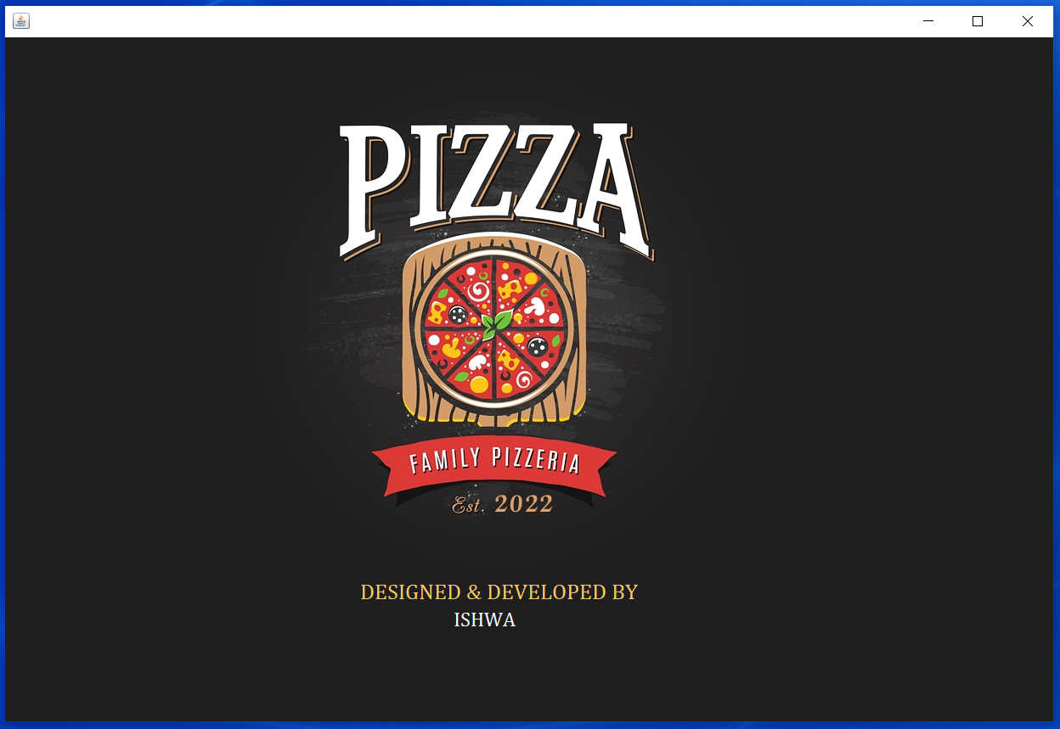

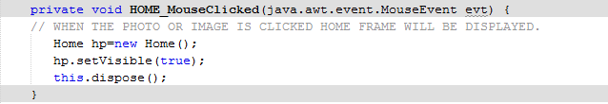

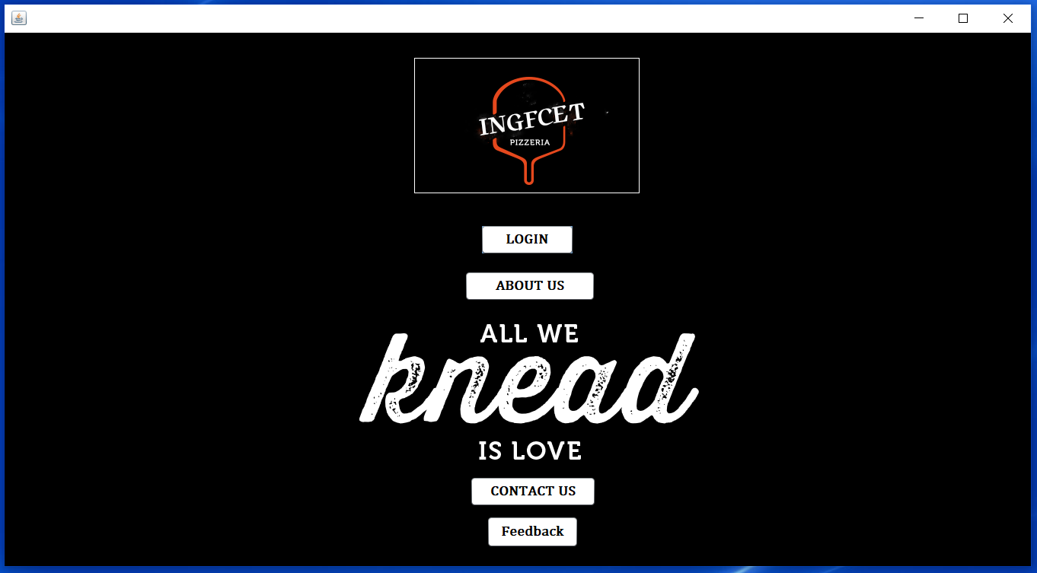

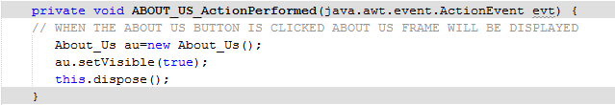

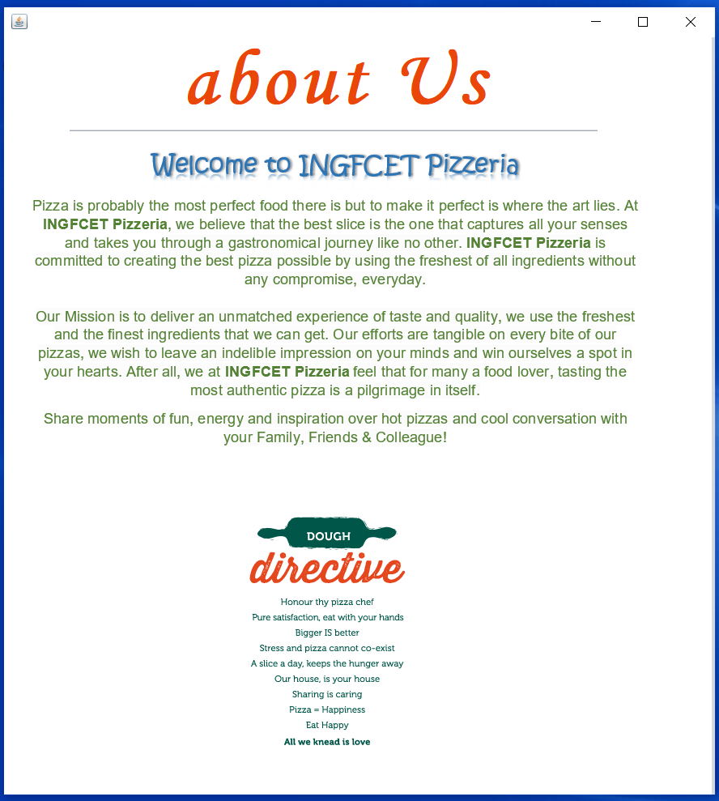

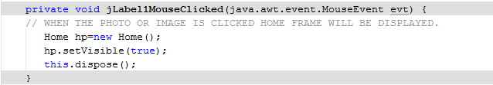



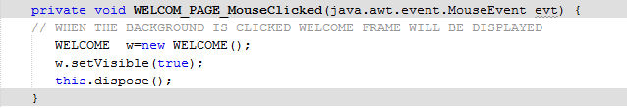

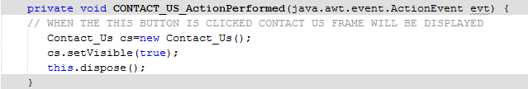

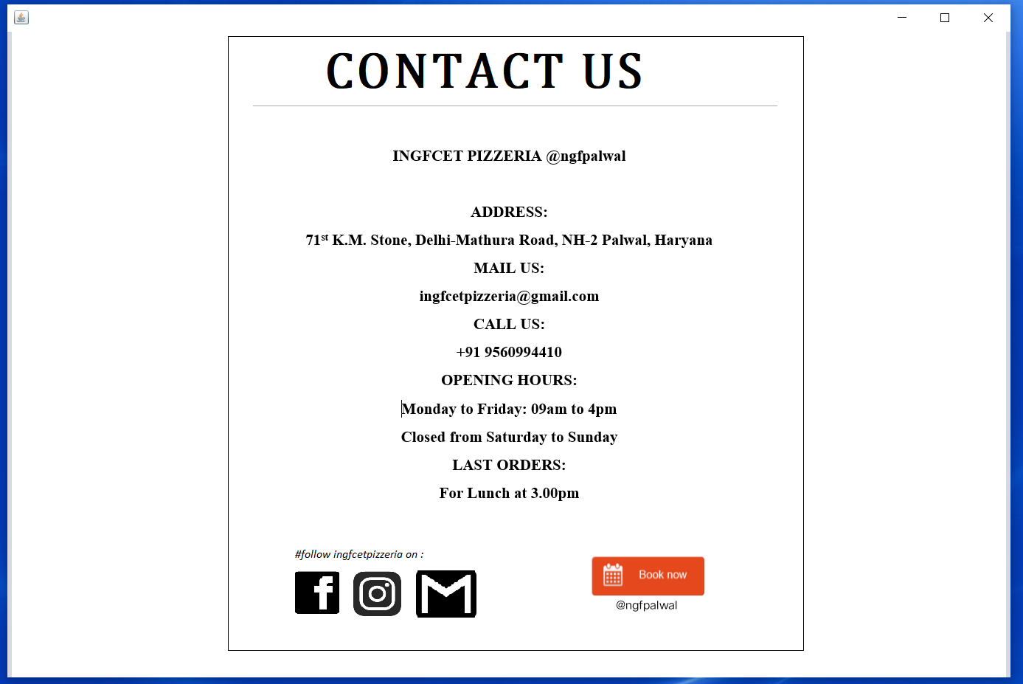

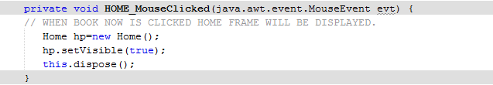



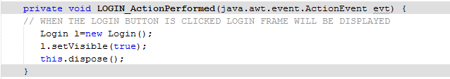

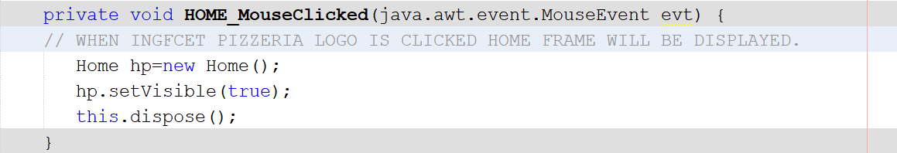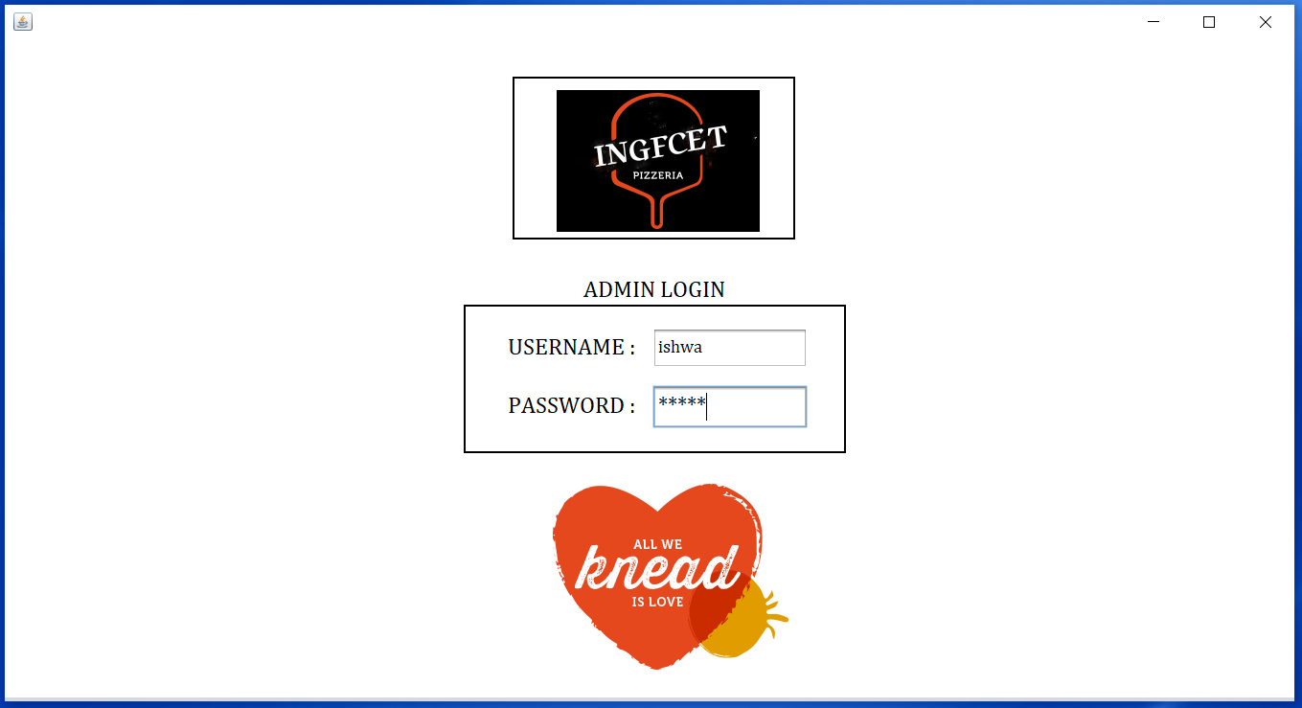

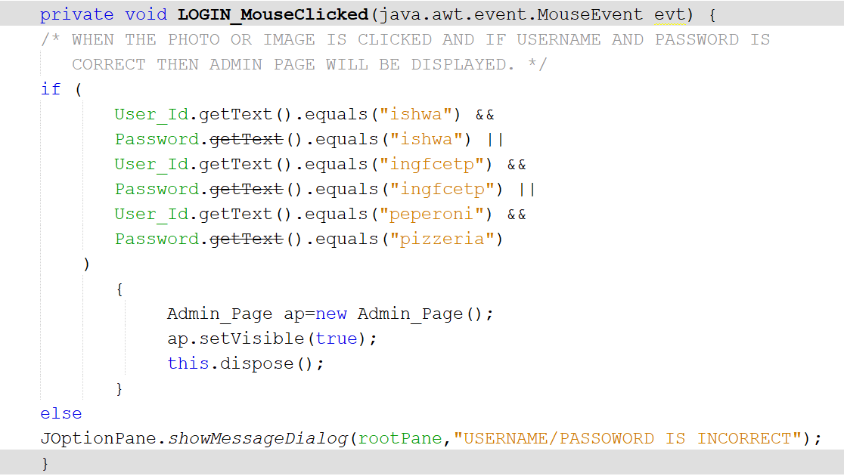

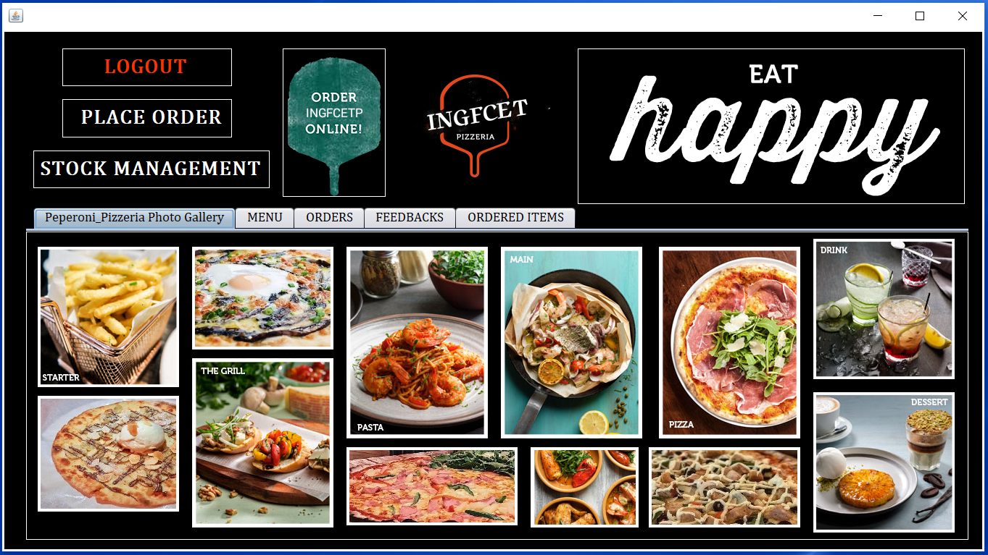

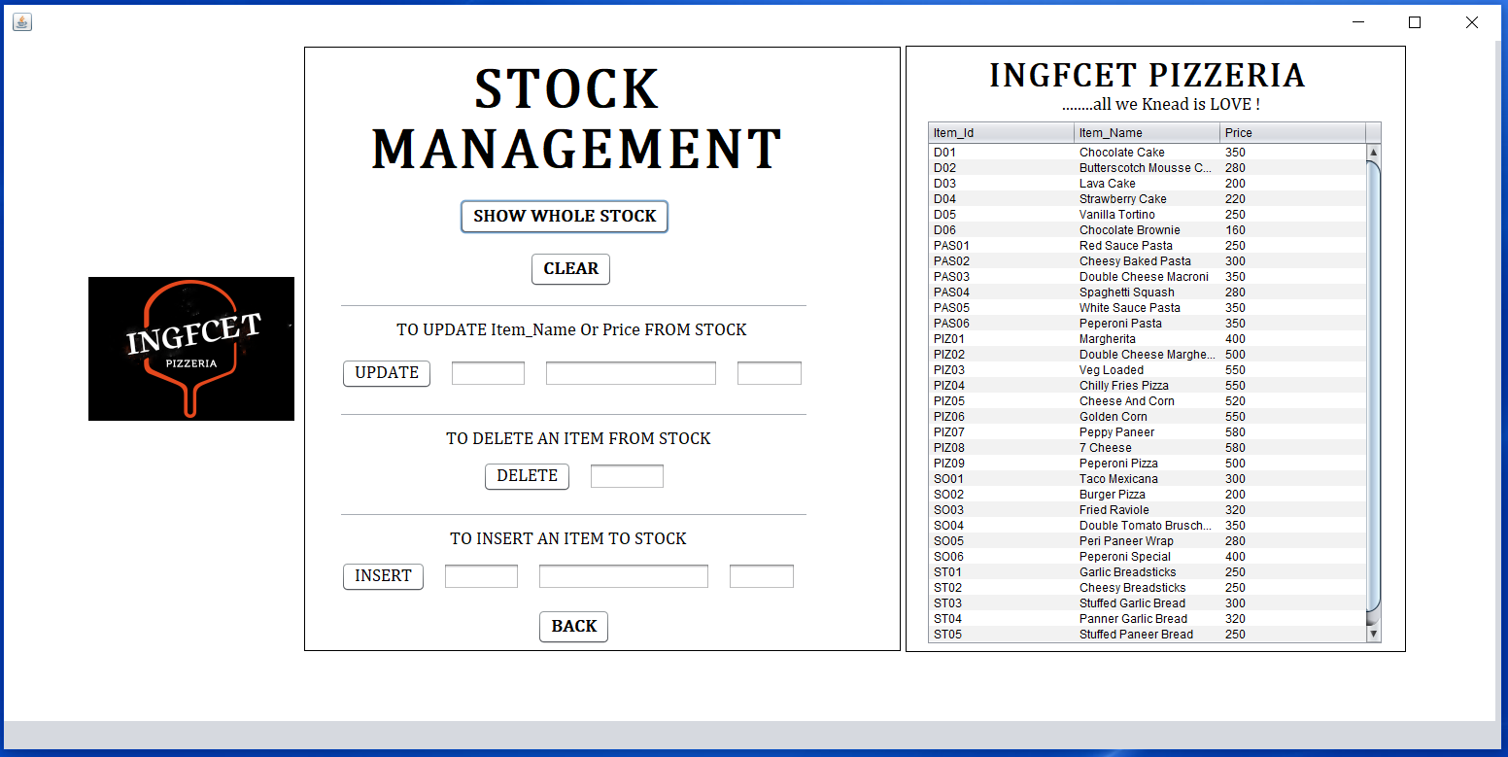

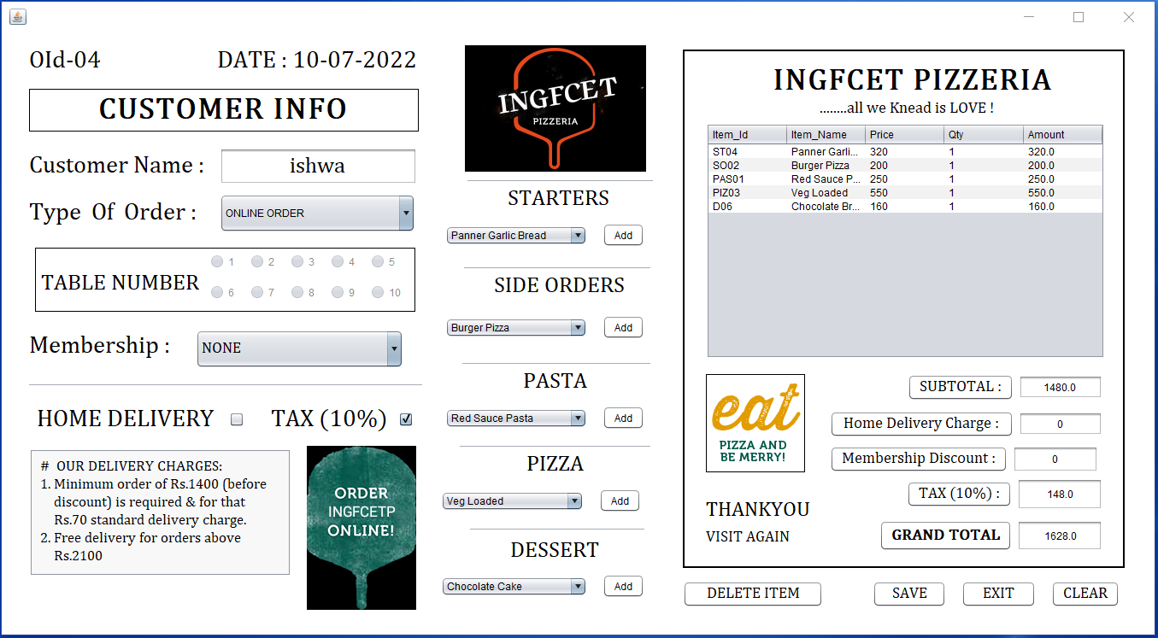



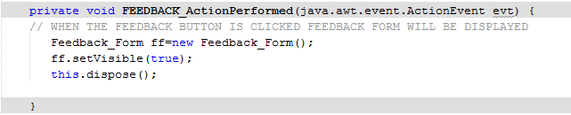

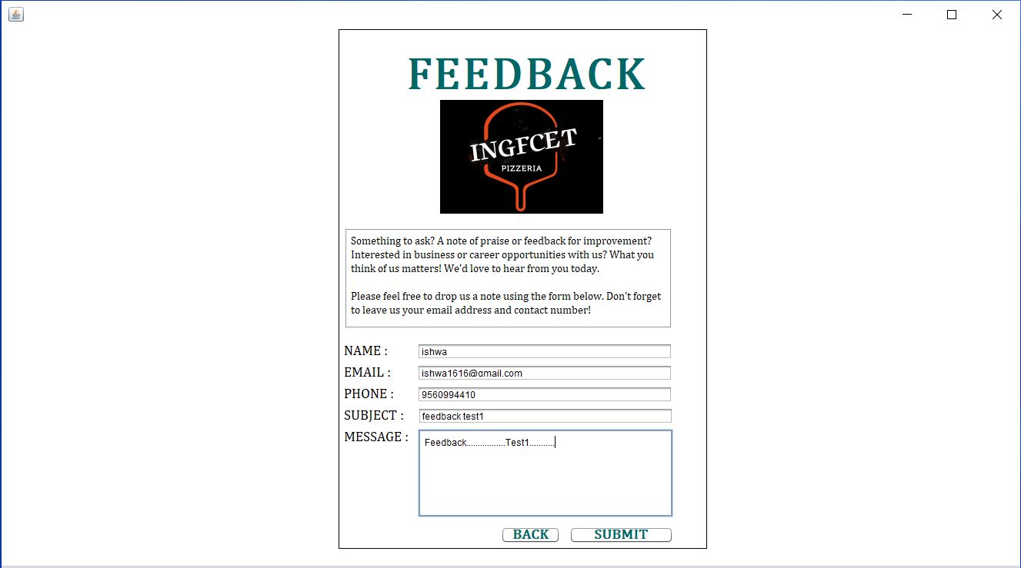

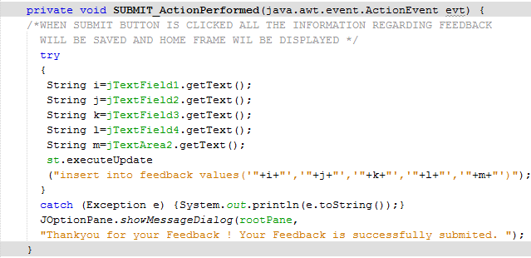

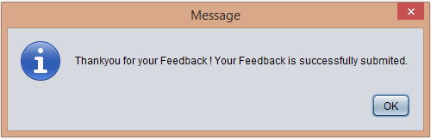

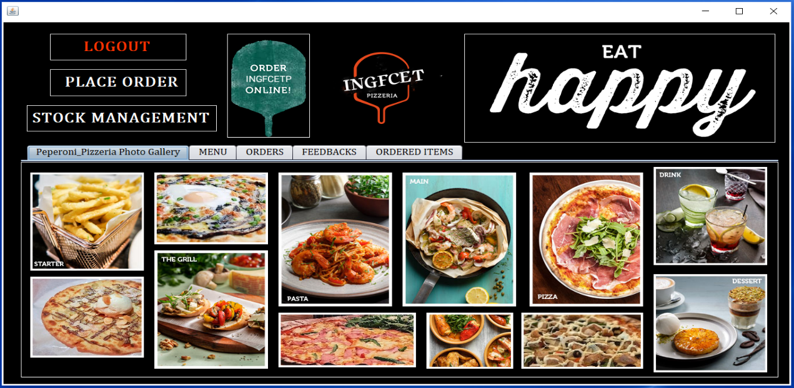





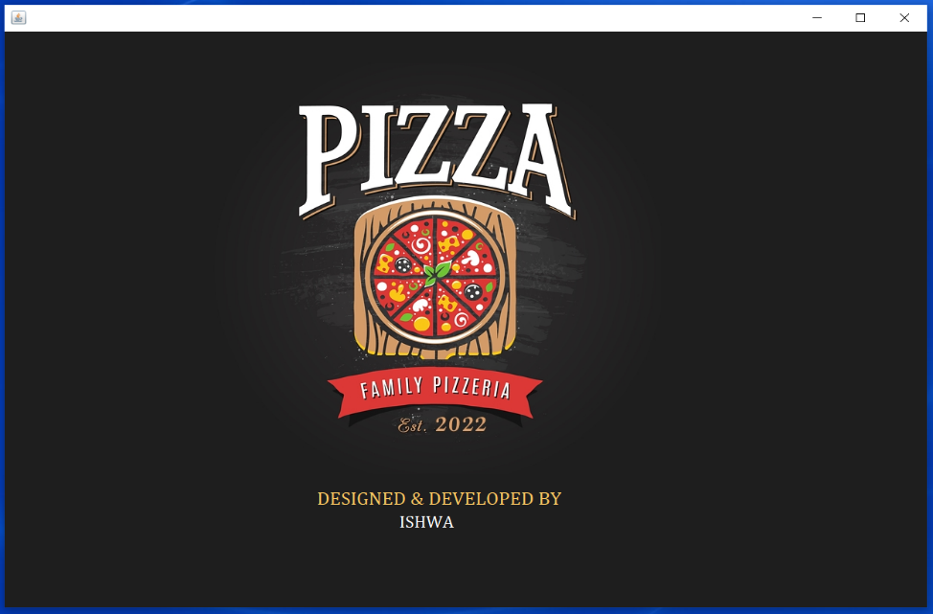

**Conclusion**

The INGFCET Pizzeria System helps the canteen manager to manage the college canteen more effectively and efficiently by computerizing meal ordering, billing and inventory control. This management system is designed for a college Canteen. The system processes transaction and stores the resulting data. Reports will be generated from these data which help the manager to make appropriate business decisions for the canteen.

This will helps the canteen owner to modify the menu easily, deduct the waiting time, helps to make life easy as the canteen by tracking all sales data, by reducing the errors, enhanced and effective Use of Human resources

Helps the canteen owner to free up the staff from performing time-consuming tasks.

**Future Scope**

1. Can be link to many food delivery websites like Zomato to increase business.
2. We can print bills of the orders.
3. Can be link to google map location features in future for fast home delivery service.
4. We can add online payment options for fast and secure payment of orders.

**THANK YOU**